Lab Exercise 1:

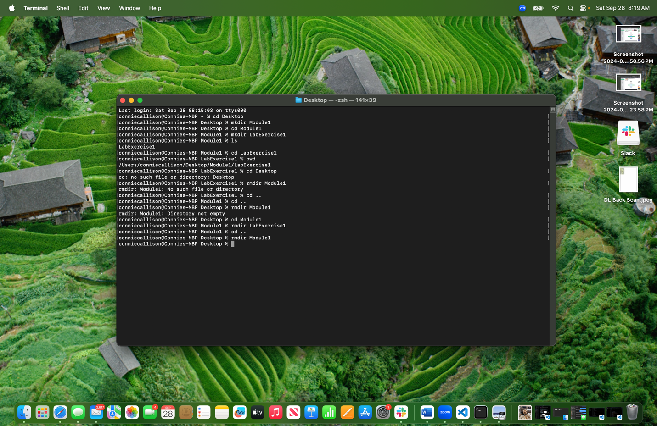

Lab Exercise 2:



